Perimeter worksheet
Question 1: Calculate the perimeter of each shape, showing full working out.
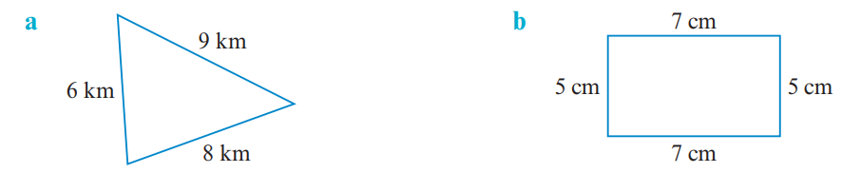

Question 2: Calculate the perimeter of each shape leaving in cm. Ensure you show full working out.
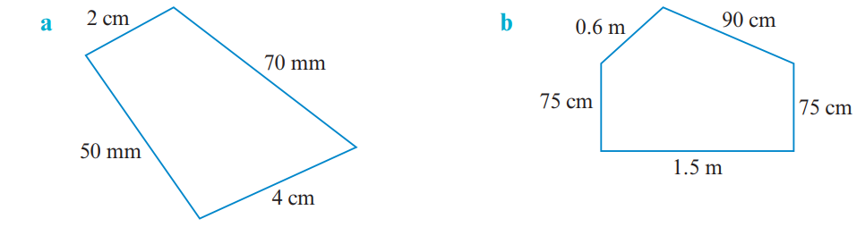
Question 3: Calculate the perimeter of each shape. Look for a shortcut to use in each case
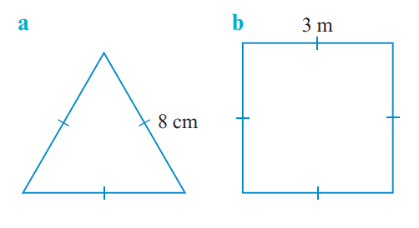

Now complete the EXIT PASS for this lesson

Perimeter EXIT PASS

